Experiment No. 4
Aim: Implement K-Nearest Neighbors (KNN) and evaluate model performance.
Theory:
1. Dataset Source
Dataset Name: Diabetes Dataset (Scikit-learn)
Source: scikit-learn library dataset

2. Dataset Description
The dataset is used to predict disease progression based on medical attributes.
Dataset Characteristics:
- Total Instances: 442
- Total Features: 10
- Target Variable: Disease progression (continuous value)
- Problem Type: Regression
Features:
- Age
- Sex
- BMI
- Blood Pressure
- Blood Serum Measurements
Target Variable:
Continuous numeric value representing disease severity after one year

2. Mathematical Formulation of KNN (Regression)
Step 1: Distance Calculation
Euclidean Distance:
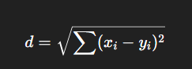
Step 2: Select K Nearest Neighbors
Choose K closest data points.
Step 3: Averaging
Instead of voting:
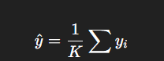

Choosing K
Small K → Overfitting
Large K → Underfitting

4. Algorithm Limitations
Slow for large datasets
Sensitive to scaling
Affected by noise
Poor performance in high dimensions
5. Methodology
Step 1: Load Dataset
- Using sklearn dataset.
Step 2: Data Preprocessing
- No missing values
- Directly usable
Step 3: Feature Scaling
- Apply StandardScaler
Step 4: Train-Test Split
- 70% Training
- 30% Testing
Step 5: Model Training
- Use KNeighborsRegressor
Step 6: Prediction
- Predict continuous values
Step 7: Model Evaluation
- Mean Squared Error (MSE)
- R² Score

Code:
from sklearn.datasets import load_diabetes
from sklearn.model_selection import train_test_split
from sklearn.preprocessing import StandardScaler
from sklearn.neighbors import KNeighborsRegressor
from sklearn.metrics import mean_squared_error, r2_score
import matplotlib.pyplot as plt
# Load diabetes dataset from scikit-learn
diabetes = load_diabetes()
X = diabetes.data # Features
y = diabetes.target # Target (disease progression)
print("Number of samples:", X.shape[0])
print("Number of features:", X.shape[1])

X_train, X_test, y_train, y_test = train_test_split(
X, y, test_size=0.2, random_state=42
)

scaler = StandardScaler()
X_train = scaler.fit_transform(X_train)
X_test = scaler.transform(X_test)
knn = KNeighborsRegressor(n_neighbors=5)
knn.fit(X_train, y_train)

y_pred = knn.predict(X_test)
# Mean Squared Error
mse = mean_squared_error(y_test, y_pred)
print("Mean Squared Error:", mse)

# R² Score
r2 = `(y_test, y_pred)
print("R² Score:", r2)
#Optional
mse_values = []

for k in range(1, 21):
model = KNeighborsRegressor(n_neighbors=k)
model.fit(X_train, y_train)
y_pred_k = model.predict(X_test)
mse_values.append(mean_squared_error(y_test, y_pred_k))

plt.plot(range(1, 21), mse_values, marker='o')
plt.xlabel("K Value")
plt.ylabel("Mean Squared Error")
plt.title("K vs MSE for KNN Regressor")
plt.show()

Output :
Mean Squared Error: 3047.449887640449
R² Score: 0.42480887066066253
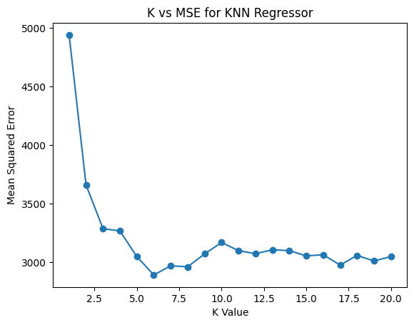
Conclusion :
The K-Nearest Neighbors (KNN) regression model was successfully implemented on the Diabetes dataset. The model achieved a moderate R² score, indicating reasonable prediction capability. Feature scaling significantly improved performance.
Unlike classification datasets, this regression problem is more complex, and KNN shows limited accuracy. The model performance depends heavily on the choice of K and distance metric.

